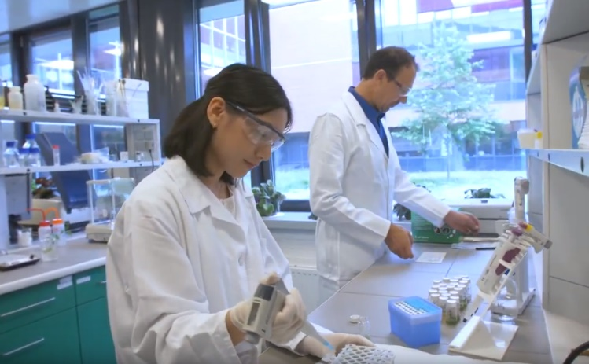
Call for proposals!

Next summer we will run the 7th summer of science internships. Do you want help with your research? Do you think you could be a good supervisor to international interns? If so: Please write a proposal of the goals of the research, the expectations of students, the learning outcomes students will gain, and the daily responsibilities of the students.

Duties of the supervisor during summer internships at Masaryk University
Basic Commitment
- Students should be employed in projects that will challenge them academically in a professional setting.
- Students must work for at least 250 hours at the workplace during the placement period (May 29 – July 20, 2023).
- Working hours should be a minimum of 8 hours a day, four days a week (during the placement period, students will be on 3 trips outside of Brno beginning on Fridays, exact dates to be determined, otherwise the schedule can be agreed upon between the student and supervisor).
- Communicate with the student before and during the internships.
- Evaluate the students’ activity and performance at the end of his/her stay.
- Supervisors receive 20.000 CZK (15.000 CZK at the Faculty of Pharmacy, additional 5.000 CZK will keep the host department).
Project proposal
- Please see the attached template to complete, but it should include the following in English.
  - Description of the project
  - Project name
  - Name of the supervisor
  - Field of study and keywords
  - Student requirements and responsibilities
- Submit to Martin Glogar at glogar@czs.muni.cz by 30.10.2022.
- Projects submitted later will be accepted based on space in the program, and topic (ease of student recruitment)
Responsibilities after student arrival
- Be available personally on Monday, May 29, and *ideally* the whole of the first week (29.5.-2.6)
- Acquaint the student with the workspace, laboratory, team, etc.
- Acquaint the student with standard practices, safety information, laboratory operating standards, etc.
- Acquaint the student in detail with the project, and contact people (if there are more than just the supervisor)
- Provide a schedule of activities for the project, including deadlines, and both day-to-day activities operations and throughout the entire placement
- Clearly present the action plan, procedures, monitoring outputs, expectations of the student, etc.
- Acquaint students with possible formal outputs (final presentation, publications, studies, etc.) This helps with understanding the bigger picture of the work they are assisting with.
Responsibilities during the placement
- Meet formally to evaluate activities and outcomes at least once a week (and, when appropriate, as requested by the student) and to provide professional feedback to the student.
- Be available to students both personally, by e-mail, or by telephone during the entire internship and communicate properly according to the students’ needs.
- Monitor the progress of research and intervene where necessary.
- Provide supervision of the safety of daily operations.
- Set up a set of evaluation elements and apply them on an ongoing basis to the research and activities. Throughout the placement, discuss with students any concerns or positive feedback.
Responsibilities at the end of the placement
- Attend and participate in the presentation of student projects (Thursday, July 20)
- Provide a final assessment and final grade on the A-F scale based on the output from the presentation, and (mainly) from the overall work done and students’ approach by Friday, July 28. The total credit value of the summer internship is 10 ECTS.

